Self-Management Review

This document contains all the necessary and structured information required for creating your own self-management review. This statement should be removed when you have read it as it is not apart of the template, it is just a discloser statement.
The “What?” will be a paragraph as you are outlining what happened in the project overall and what you would consider changing.
The “So What?” could be a few lines or a paragraph as you are then clarifying why the “What” is important.
The “Now What?” is lessons you have learnt and what you would consider doing differently for future projects.

Reporting period 1: Week 1 to Week 4

Meeting agenda & minutes with Client

Experience
We do not have any meeting minutes or an agenda with our Client, Geoff from the first 4 weeks. Our Capstone Manager that was Dave Sushames at the time, would schedule meetings through email which is the standard way of doing so. However, most of the work the team did in the first four weeks of Capstone was very practical and hands-on rather than any online or formal in-person meeting.
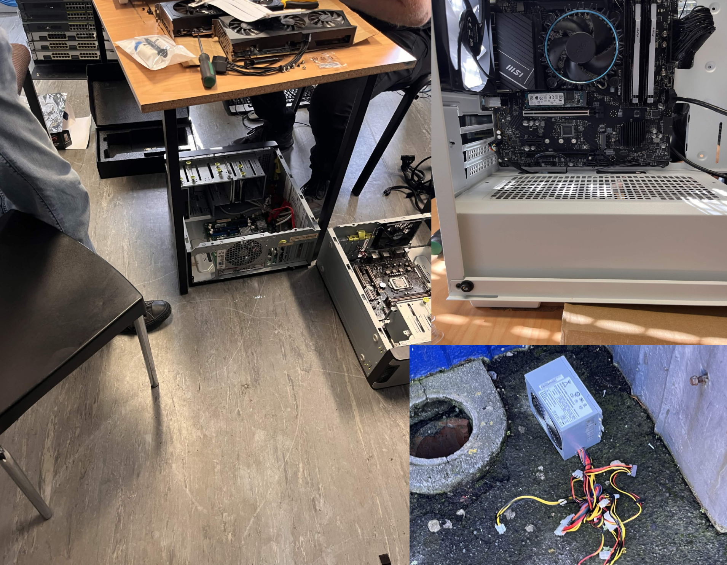

Reflection
In hindsight, the team should’ve been writing meeting notes despite the fact that our meetings were quite informal. Meeting notes and agendas are essentially the record that the meeting occurred and its grown increasingly more important overtime, how important it is that these records exist as evidence.

Action
The action going forward is to have someone on our team be assigned to making the meeting agenda and notes for meetings with our client. As the previous person was Olivia and Dave acted as Project manager, these roles were exchanged and so Dave became primarily in charge of handling meeting notes.

Meeting agenda & minutes with Advisor
BDSH Advisor Meeting Minutes (Week 4)
DATE: 06/08/26 | TIME: 12:00PM
LOCATION: T7 Meeting room
ATTENDEES: Clement Swarnappa, Dave Sushames, Matt Baker, Olivia Hey, Sam Davies
APOLOGIES: N/A | NON-ATTENDEE(S): N/A
MEETING LEADER: Dave Sushames, Matt Baker | MINUTES TAKER: Olivia Hey

PROJECT NAME: AI vs Legacy Digital Forensics Tools – A Comparative Efficacy Analysis
PROJECT PURPOSE: Provide an empirical analysis on AI digital forensics technologies
MEETING PURPOSE: Find assistance in preparing the project proposal

AGENDA ITEM: | LED BY (Initials Only): | TIME  ALLOTTED:
State of the project, proposal | MB | 15
Find a new methodology, discuss problem of two competing methodology requirements | DS | 15
Clarification on the client contract | MB | 15
Discuss scope and requirements gathered from our previous meeting with geoff | DS | 15

ACTION ITEM: | DELIVERABLE(S):
Generate meeting minutes, adapt a template, send to clement for signing | Meeting minutes with signature section
Select an appropriate simple methodology that we have used previously | Present methodology

MEETING NOTES:
Proper decorum when organizing meetings
-Agenda should be provided beforehand, meeting minutes after for signing
-Send as word documents in email
-Have meeting 1 and 2 signed before meeting 3
Dave will send proposal document after meeting for clement to review
12:20
Clarification on the client contract, says we should send it to Geoff
We don’t have an advisor to talk to about the forensics side of things
12:30
Methodology discussion
-Hybridization is a possibility
- 1 methodology for testing, 1 for project management
- Kanban?
- Dave needs to make project management documents
-Clement likes using Trello for kanban
- research kanban, update methodology section accordingly
12:40
We can use kanban to improve accountability
Discussion about the review panel
- Provide equivalent work to hours contributed
- Annotate research logs for each piece of work
- Create work for ourselves
- Clarify our titles/roles
Next week there is NO MEETING

Ends at 1pm

DETAILS OF NEXT MEETING: Will be Mon/Tue/Weds the week after next
DATE: N/A | TIME: N/A
LOCATION: T7 Meeting room
MEETING CLOSED: 1pm

SIGNATURES
Name: Clement Swarnappa | Role: Advisor | Signature:
Name: Dave Sushames | Role: Project Manager | Signature: Dave Sushames
Name: Matt Baker | Role: Digital Forensics Technician | Signature: Matt Baker
Name: Sam Davies | Role: Digital Forensics Technician | Signature: Sam Davies
Name: Olivia Hey | Role: Digital Forensics Technician | Signature: Olivia Hey

Experience
These notes were written by Olivia, at the time when Dave was still project manager. Olivia was taking a notepad into the meeting and writing them down physically. This was the week in which the Proposal was due. These does cause extra write-up as physical notes need to be converted into digital copies.

Reflection
The biggest problem is that during this meeting, Clement directly mentions the notes which are documented below and then his feedback isn’t followed up on for this set of notes.
“-Proper decorum when organizing meetings”
“-Agenda should be provided beforehand, meeting minutes after for signing”
“-Send as word documents in email”
“-Have meeting 1 and 2 signed before meeting 3”
All of these notes imply that something went poorly during the email communications. This would’ve been Dave’s responsibility at the time, but the rest of the team could’ve collectively voted to change the Project Manager role earlier than we did because this problem was addressed but nothing ended up happening. These notes are also missing the signature from Clement. A thing we did really well on with note-taking is that the timestamps and template are used consistently and well.

Action
Have the Project Manager use a calendar notification to remind themselves to email beforehand and also further follow up with the meeting attendee’s so that these steps turn into a habit and each meeting gets more consistent. It may also be of benefit to have the team members do the same so that the team may remind each other.

Gantt Chart
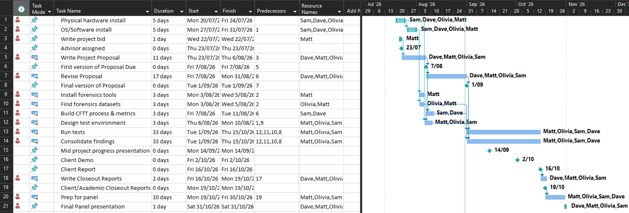

Experience
This Gantt chart was made before our final version of the proposal was handed in and as such, our Gantt chart does not reflect the path that was taken. For example, “run tests” or “design test environment” isn’t something that can really be defined as an activity because you can’t exactly “test” the quality of reports. Reports can be compared to statistics, they can be refined and reviewed but they can’t be ‘physically’ tested in the way code can.
The proposal heavily changed over the course of two weeks as the project was guided by advisors. The original focus behind the project was to test DFIR tools that use AI to perform the same core-functionality as traditional tools for a direct comparison. However, testing these tools over the course of the earlier weeks lead to discovering that these tools do not exist in the way we imagined. The aim of the proposal shifted to testing the AI output of reports when given the same dataset results as a forensic examiner and as such, the Gantt chart does not look the same way it did anymore.

Reflection
It’s difficult to say whether the Gantt chart has been helpful for the team at any point. A lot of changes have occurred to it due to the shift in project direction and the lack of consistency with the chart hasn’t helped. The team weren’t checking nor updating the chart often, so it hasn’t been as helpful as it could’ve been.

Action
Regularly updating and checking the Gantt chart and spreading out milestones so that the team can motivate themselves to work towards the next milestone.

Team Weekly report
Category | Matt Baker | Sam Davies | Olivia Hey | Dave Sushames | Total hours per category
Team meetings | 4 | 4 | 4 | 4 | 16
Client meetings | 45m | 45m | 45m | 45m | 3
Advisor meetings | 1 | 1 | 1 | 1 | 4
Research | 2h 30m | 12h 35m | 8h 10m |  | 23h 15m
Development | 1 | 1 | 1 | 1 | 4
Testing
Sick Leave
Documentation | 8 | 5 | 6h 45m | 10h 30m | 30h 15m
Other |  |  | 30m |  | 30m
Total hours per team member for this week | 16h 45m | 24h 20m | 22h 10m | 17h 15m | 80h 30m
Running total per team member | 46h 15m | 41 | 46 | 40

Team meetings:
Tuesday 10am – 11:30am. Attempted to have a meeting with Geoff, but he wasn’t able to make it, so we discussed our project proposal and who was covering which sections.
Friday 10:15am – 12:45pm. Group call where we went over the proposal and Dave made last minute edits.
Client meetings:
Wednesday 1:30pm-2:15pm. Recorded meeting with Geoff regarding requirements and deliverables.
Advisor meetings:
Thursday 12pm – 1pm. Meeting with Clement discussing what needs to be kept track of, and how the proposal is going. Sent him the current proposal draft for feedback.
Development:
Showing the team the git repository, catching them up on how git works, showing how to commit/push, and resolve basic merge conflicts.
Documentation:
1 hour each for individual logs.
Work on respective parts of proposal.
Olivia: Project Objective
Sam: Project Plan
Matt: Project Personnel
Dave: Timeline, Risk analysis, Gantt chart.
Other:
Olivia spent 30 minutes editing the video footage from Geoff’s interview.

Experience
The team always holds a team meeting at the beginning of the week on either a Monday or Tuesday. During these meetings, Dave consolidates the Weekly report while the rest of the team prepares their individual logs a day prior to the meeting. This meeting time is used to check that the records written within the weekly report correctly add up and remain consistent across persons.

Reflection
Ask for daves personal reflection as the weekly group reports have remained his task for the entire trimester
During the first few weeks, the team missed a weekly log hand-in which resulted in the need to use the backup checkpoint. In actuality, there should’ve never been the need to use the backup checkpoint if the team had planned to hand-in things properly by setting reminders and forming a schedule. This would mean any future failures to hand-in on time would not be able to be uploaded and result in a week of missing logs for the whole team.

Action
As above, wait for daves input.

Reporting period 2: Week 10 to Week 12

Meeting agenda & minutes with Client
BHB Meeting Agenda
DATE: 11/09/26 | TIME: 10:00
LOCATION: Remote Meeting via Zoom
ATTENDEES: Geoff Gordon, Dave Sushames, Matt Baker, Olivia Hey, Sam Davies
APOLOGIES: n/a | NON-ATTENDEE(S): n/a
MEETING LEADER: | MINUTES TAKER: Dave Sushames

PROJECT NAME: AI-Enhanced vs Legacy Digital Forensics Tools – A Comparative Efficacy Analysis
PROJECT PURPOSE: Provide an empirical analysis on Ai-augmented digital forensics technologies
MEETING PURPOSE: First Geoff meeting in a while.

AGENDA ITEM: | LED BY (Initials Only): | TIME  ALLOTTED:
1. Apologies | N/A | N/A
2. Action items from previous minutes | N/A | N/A
3:
4:
5:
6:
7:
8: Any other business
9: Assigning next meeting date and time

ACTION ITEM: | DELIVERABLE(S):

MEETING NOTES: Geoff 11/09
1000 Greetings, explaining what the mid project presentation is about
1010 Discussing change in project scope, Bryce’s suggestions
1020 AI is a challenge to get it to work with DF tools, so the answer to the project is probably “no”, we just have to justify that answer.
1030 Limitations of AI, Snellen charts. Context lengths.
1040 Gemma is good because it has a decent context window. Tool looping is an issue (“I’ll read that again. I’ll read that again. I’ll read-“).
1050 Arranging a time for the presentation.
1100 Discussing project management methodologies, Scrum.
1110 Covering weekly hours.
1120 Pro tips on management techniques
1130 New computers. LLMs have different layers, with each layer on a different machine.
1140 Methods of recovering data. Can’t recover data if you destroy the hard drive.
1150 Advice on doing the presentation
Meeting ended 1200

DETAILS OF NEXT MEETING:
DATE: | TIME: 1000
LOCATION: Discord
MEETING CLOSED: 1200

Experience
By Week 10, the team is producing documentation for meetings that were held with the client.

Reflection
The positive thing about the notes are the timestamps for each topic and the consistent use of a template. These notes appear to be lacking the agenda for the meeting and the signature from the client. This is notably something which the team should be paying attention to because it is more consistent within advisor notes but didn’t occur for this client meeting. Some of the wording is informal and the action item/deliverables table isn’t used whatsoever.

Action
The team should consider removing tables from the set meeting notes if they remain unused. A standard should be put in place that all notes should be held to so they remain consistent. This would entail asking for the client’s signature and frequently checking the completed document to make sure the notes are meeting the standards that are put in place.

Meeting agenda & minutes with Advisor
BDSH Advisor Meeting Agenda
DATE: 14/09/26 | TIME: 11:00am
LOCATION: On Campus, Level 7
ATTENDEES: Clement Swarnappa, Dave Sushames, Matt Baker, Olivia Hey, Sam Davies
APOLOGIES: N/A | NON-ATTENDEE(S): N/A
MEETING LEADER: Olivia Hey | MINUTES TAKER: Dave Sushames

PROJECT NAME: AI - Augmented vs Legacy Digital Forensics Tools – A Comparative Efficacy Analysis
PROJECT PURPOSE: Provide an empirical analysis on Ai-augmented digital forensics technologies
MEETING PURPOSE: Advisor meeting for mid project presentation

AGENDA ITEM: | LED BY (Initials Only): | TIME  ALLOTTED:
Introductions | N/A | 5m
Progress update | MB | 15m
Discuss Sam hours | SD | 15m
Mid project presentation | OL | 20m

ACTION ITEM: | DELIVERABLE(S):

MEETING NOTES:
1100 Greetings, basics of mid project presentation.
1105 Presentation is all but ready. Who is doing what work? We’re up to Tenmost now.
1110 Making sure everyone has enough work. Documentation, test cases, reporting. Can share the work around, especially scripts and such.
1115 Design science: Artefacts. Check the marking rubric (ask Dax if there isn’t one). People can dig deep into what artefacts are generated/apply to the project. How frequent should they be, eg 3 per sprint? Follow the methodology.
1120 Standardise the test plan. User, UX, utility testing etc.
1125 Discussing Sam + Dave’s logs.
Option 1: Ask Dax to reopen dropbox.
Option2: Matt/Olivia give up their backup dropboxes?
Option 3: Leave it as it. We can keep the logs for the final panel.
1145 Print the rubric before the next meeting, we can go over it to figure out what needs to be done.
Meeting ended 1200

DETAILS OF NEXT MEETING:
DATE: N/A | TIME: N/A
LOCATION: T7 Meeting room
MEETING CLOSED: 12pm

SIGNATURES
Name: Clement Swarnappa | Role: Advisor | Signature: Clement Swarnappa 16/09/26
Name: Olivia Hey | Role: Project Manager | Signature: Olivia Hey
Name: Matt Baker | Role: Digital Forensics Technician | Signature: Matt Baker
Name: Sam Davies | Role: Digital Forensics Technician | Signature: Sam Davies
Name: Dave Sushames | Role: Tester | Signature: Dave Sushames

Experience
In this set of meeting notes, the advisor has signed approval and there is a clear, scheduled agenda with initials and time allowances for each agenda item. The meeting notes themselves have attached timestamps and are clearly understandable.

Reflection
The only improvement that could possibly be made is removing the action item and deliverable box because it is empty and taking up space. For the most part, there is not much room to improve.

Action
Keep the following sets of notes as consistent as this set is. This can be done by having the same person writing the notes for every meeting if they are available and prepare them with the same method.

Gantt Chart
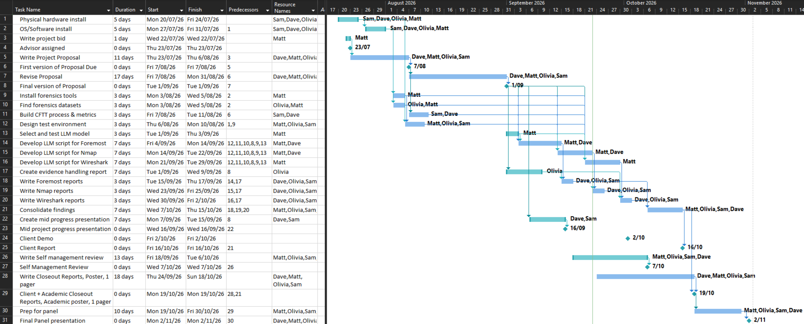

Experience
The week 10-12 Gantt chart is approximately the third iteration of the Gantt chart as the proposal allowed for the stages of the project to be changed and developed further. There are many more activities that have been included and the timeline has shifted. Compared to the first iteration, there are a rough estimate of 10 new event additions altogether.

Reflection
The new additions give a sense of the timeline that is left. Ask for Daves opinion

Action

Team Weekly Report
Category | Matt Baker | Sam Davies | Olivia Hey | Dave Sushames | Total hours per category
Team meetings | 5 | 6h 30m | 6h 30m | 6h 30m | 24h 30m
Client meetings
Advisor meetings | 3h 30m | 3h 30m | 3h 30m | 3h 30m | 14
Research | 2h 30m | 15m | 8h | 2h 50m | 13h 35m
Development | 11h 45m | 10 |  | 12h 15m | 34
Testing | 8h 15m |  |  |  | 8h 15m
Sick Leave
Documentation | 1 | 1 | 9 | 12h 30m | 23h 30m
Other |  |  | 3 |  | 3
Total hours per team member for this week | 32 | 21h 15m | 30h | 37h 35m | V 120h 50m
Running total per team member | 276h 30m | 207h 15m | 254h 30m | 258h 25m

Team meetings:
Monday 1-2:30pm Catching up on what everyone has been doing, assigning tasks for this week.
Tuesday 10-12pm: Discussed work to be done, audited weekly logs.
Thursday 1-3pm: Assigning tasks: Matt demonstrating JSON and CSV files as different methods of LLM integration. Olivia is doing the Review. Dave is doing the Poster.
Friday 10:30-11:30: Debrief after Bryce’s meeting, discussing how to work on the scripts.
Client meetings:
Advisor meetings:
Tuesday 9-10: Bryce meeting, discussed accessing Bryce’s network for Nmap scanning. Deciding a good program to make the poster in, as Publisher is discontinued in October.

Friday 8-10:30 Bryce meeting. Discussed Matt’s scripts, standardising files, and converting the AI reports into a more readable format.
Documentation:
1 hour each for individual logs.

Experience
In Week 11, the template for the group weekly logs remains the same. The team have begun recording time metrics in 15-minute chunks rather than 5-minute chunks which greatly reduces the amount of time it takes to calculate log hours. This a change that should’ve been input in the first 4 weeks but wasn’t. These logs have a small error in that they are missing the ‘h’ and ‘m’ marks for a handful of columns.

Reflection

Action

